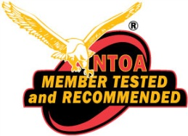
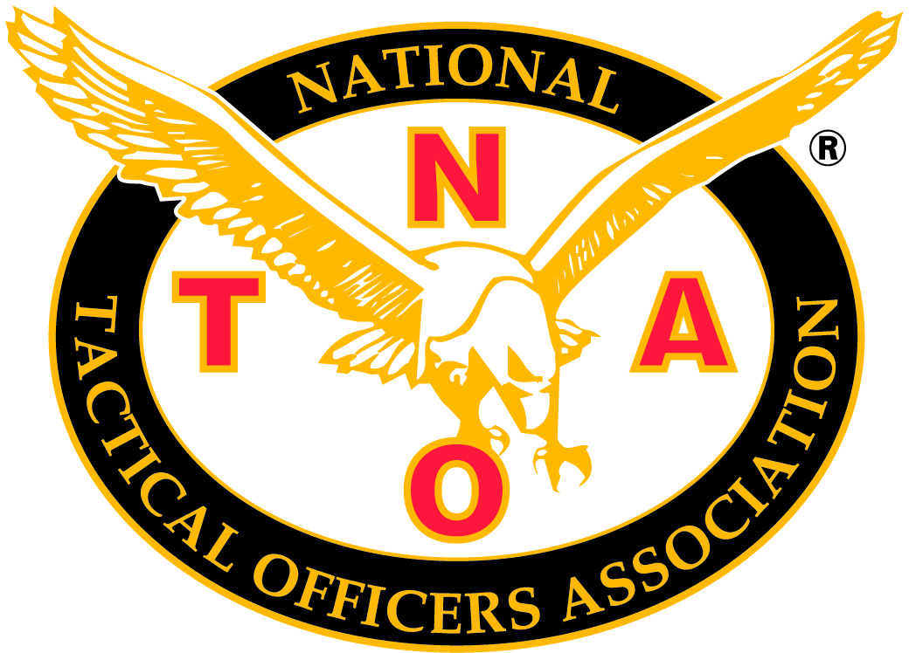

July 31, 2026

Thank you for participating in our “Member Tested and Recommended Program.” The VP 100 Combat Dagger has been tested and recommended by the members of the National Tactical Officers Association. Your overall score was a 4.01.

Attached with this letter is the Member Tested and Recommended logo which may be used solely with the specific product that was tested. The logo can also be used on all marketing pieces for this product, website and press releases. Attached is a copy of the complete reviews that your company can use as well.

Press releases written regarding this product review must be emailed to the NTOA for review before release to assure the wording is correct.

This product and its reviews are now listed on the NTOA’s Member Tested and Recommended online database. The reviews may also be published in The Tactical Edge journal, as time allows. Please send a digital image of the product that has been tested to katina@ntoa.org so we can add it to the online database.

Please contact Corey Luby at advertising@ntoa.org if you would like to advertise in The Tactical Edge journal. Once again, thank you for participating in the Member Tested and Recommended Program©.

Katina Madianos-Fiore
Member Tested and Recommended Program Coordinator
800-279-9127 x116

phone: 800.279.9127 | fax: 215.230.1807 | PO Box 797, Doylestown, PA 18901 | www.ntoa.org
BESH Knives, Inc.
VP 100 Combat Dagger
Overall Score: 4.01
www.beshknives.com
Tester 1 of 4
Tested by a member from Oregon
Design 5
Performance 5
Ease of Use 5
Size 4
Quality 5
Durability 5
Storage 4
Versatility 3
Convenience 4
Application 3
Comfort 3
Accuracy 4
Cleaning & Maintenance 5
Individual Score 4.23
The VP-100 Dagger is phenomenal. It is designed to be extremely strong and it did not disappoint. I attempted to put the dagger through its paces, but that can be hard to do unless you work in a butchers shop. There's no easy way to say it, but the dagger was designed with close combat in mind. It is designed to kill people by piercing through several inches of flesh. I was not confronted with an opportunity to use it for its intended purpose, but fortunately I had some pork loin in the fridge. The VP-100 had no trouble stabbing through the pork with ease. It also sliced quite well. The partial serration in the blade was a great idea. The VP-100 is well-balanced. I practiced throwing the dagger at several trees and it performed very well (much better than I did). After numerous throws into the wood and into the ground, there were no signs of the abuse the dagger was surely taking. It is a very durable knife. The sheath is solid and versatile. It can be worn several ways and is easy to use. I don't think I would feel comfortable wearing it upside down on a vest due to retention issues. My only concern with the VP-100 is the practicality. I'm not sure there is much of an application for a full-sized combat dagger in police work. It is too large to be concealed for patrol. It is also quite large for my tactical vest (a little over a foot long). I would like to see a slightly scaled down version of this dagger. It is a great piece of equipment and is clearly built very well.
Tester 2 of 4
Tested by a member from South Carolina
Design 3
Performance 3
Ease of Use 3
Size 3
Quality 3
Durability 4
Storage 2
Versatility 3
Convenience 3
Application 3
Comfort 2
Accuracy 2
Cleaning & Maintenance 3
Individual Score 2.85
I put the Besh Knives VP-100 Combat Dagger through a pretty tough testing. The blade seemed to hold up OK in use. I wasn't impressed with the handle. I am used to a little thicker handle and my hands seemed to slip when using the knife under a heavy load. The knife was too big to mount to my tactical vest so I had to use the belt loop attachment. This is not a knife that I would go out and buy to use for myself. I do like the knife sheath and the material it's made of. The only thing I would add is a better locking system to hold the knife in the sheath. I used the knife to do some prying and the blade seemed to hold up well under stress. I currently use a Marine Corp-issued combat knife/bayonet that is a great prying tool when needed. Overall, I think this knife would be OK for Special Ops use.
Tester 3 of 4
Tested by a member from New York
Design 5
Performance 5
Ease of Use 5
Size 4
Quality 5
Durability 4
Storage 5
Application 2
Individual Score 4.38
The VP-100 is not a field knife. It is mission-specific geometry designed and engineered to meet the needs of today's soldiers and the demands of the modern battlefield. Balanced with weight forward for fast response and precision machined from AUS-8 stainless steel, the VP-100 includes a custom-designed Rapid-Draw Sheath, a versatile 8-Hole Multi-Position Belt Buckle and mounting plates for vertical or horizontal attachment to any Molle platform. Its ergonomic handle features strategically placed scallops and texturing that together with an integral double guard ensure a positive combat grip, whether forward or reverse, with or without gloves, even under the most demanding circumstances. (The preceding is from the manufacturer's website.) This dagger was made with quality materials and it stood up to my team's testing. We used it to cut thick rope, cut through sheetrock, dropped it in the floor and threw it across a room. The blade stayed sharp and the knife did not fall apart or break in any way. It comes with a mounting plate to attach to a tactical vest and it appeared to hold up well. I think it would be somewhat rare to be in a situation where there would be a need to use a weapon like this in a hand-to-hand environment but it still can be a handy tool to have on your kit if the need ever arose.
Tester 4 of 4
Tested by a member from Oklahoma
Design 3.99
Performance 3.99
Ease of Use 5
Size 4.85
Quality 5
Durability 5
Storage 4.5
Versatility 3.5
Convenience 4.5
Application 4.5
Comfort 4.5
Accuracy 4.5
Cleaning & Maintenance 5
Individual Score 4.56
The VP-100 Combat Dagger is a very sturdy knife. The look of the Besh Wedge tip takes a little getting used to. This knife was like none I had ever seen before. This is a purpose built knife. Its purpose, combat. The blade on this knife is extremely sturdy. No flex at all. I liked the fact that it was a one piece blade/handle combination. It is manufactured out of stainless steel. The unique tip and the double beveled edges make this the ideal knife to use if needed in a tactical operation as a backup weapon. The knife is not designed to be your primary operating knife used for cutting 550 cord. The sheath that comes with the knife is easy to work with and has several different carry options. The two ways I chose to carry during the test and evaluation process was on my belt and a Molle mount on my entry vest. My only knock on this knife would be the hand guard. The guard is not very big. I could see the small guard being problematic if this knife was used by the operator to defend himself on a mission. The possibility of one's hand sliding past the small hand guard and down to the blade is a very real concern. Overall, this is a very well-constructed weapon. I would definitely recommend adding this knife to your kit if you are looking for a reliable back up weapon.

