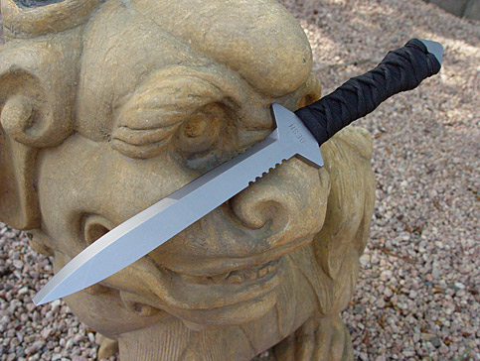
Brent Beshara's Extreme Dagger: The XSF-1
Review by Michael Janich
When it comes to making a knife, most folks generally agree that there are three basic phases to the process: design, engineering, and execution. While most knives are the product of a reasonable balance of these three elements, truly great knives get it all right, combining a great concept with superior planning and expert execution. And one excellent example of this unique synergy is Brent Beshara's XSF-1 dagger.
In case you're not familiar with Beshara, you should first understand that an appreciation of his knives must begin with an understanding of his background. A career enlisted man in the Canadian army, Beshara is an expert in explosive ordnance disposal (EOD) operations, a certified EOD instructor, a combat diver, and veteran of numerous years of service in the Canadian army's most elite special operations unit. His service and training has taken him all over the globe, including extensive training and operational experience with other special operations units and multiple operational deployments to Afghanistan.
In addition to his military skills, Beshara is also an accomplished martial artist with more than two decades of training in the Chinese martial arts and an eclectic blend of military combatives and other fighting arts. And, as explained previously in the pages of this magazine, Beshara is also a close friend and apprentice of Master Bladesmith Wally Hayes and an accomplished knifemaker in his own right.
With such an extraordinary combination of qualifications, it's not surprising that Beshara would design, engineer, and produce some very special knives. However, no knife that I've come across in recent years is as unique as the Beshara XSF-1 dagger.
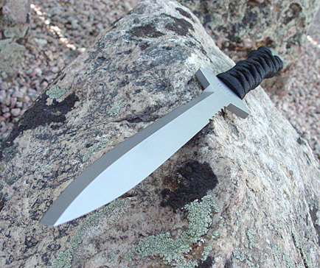
Most knife aficionados are familiar with the classic double-edged dagger design and its diamond-shaped cross section. Folks who have been around knives a while may have even seen some of the more unusual dagger variants, including those with triangular cross sections, fullers, and even cruciform (cross-shaped) cross sections. However, the XSF-1 is more unique than even these unusual variants because it features a triple-edged point design - known also as "Besh Wedge Technology."
Besh Wedge Technology was born when Beshara was working on a modern interpretation of a classic military dagger. Because grind symmetry is so important to the proper look of a dagger, it is not unusual for makers to grind the opposing (diagonally opposite) bevels to establish the initial look of the knife. They would then grind the remaining two opposing bevels to define the centerline and the final lines of the blade.
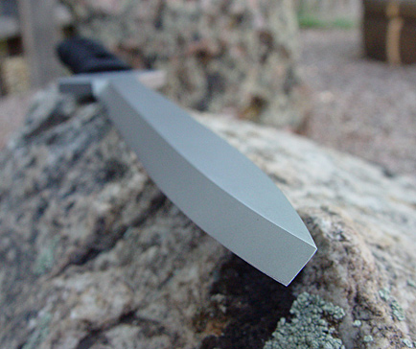
This view of the XSF-1 shows how its dual chisel grinds converge to form a third cutting edge at the tip of the knife that is substantially stronger than typical dagger points
In Beshara's case, after grinding the first two bevels of the blade, he took a close look at the way the lines began to converge at the tip and realized that they began to shape a chisel edge almost like the sharpened tip of a flat screwdriver. Fascinated with the potential of this unique edge geometry, he ground the bevels deeper until he had a dagger with two diagonally opposite chisel-edged bevels. The two sharpened edges of these bevels met at the tip of the blade in a third edge that appeared to have substantially more strength and structure than a traditional dagger point. It also produced one of the most distinctive "looks" of any knife I've ever seen.
To evaluate the potential of his new design, Beshara immediately heat treated the blade and set about doing some testing. Since the primary function of any dagger is as a thrusting weapon, most of Beshara's testing was centered around that type of application. What he found was that his new design not only penetrated amazingly well, it eliminated the main shortcoming of traditional dagger designs: a fragile and easily broken point. With that, the XSF-1 was born.
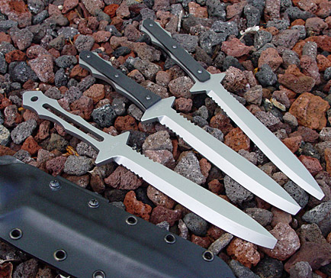
In its custom configuration, XSF-1 is an 11-3/4-inch full-tang dagger with an integral double guard and a 6-3/8-inch blade. Available with either a plain steel handle, G-10 handle slabs, or an epoxy coated Japanese-style cord-wrapped handle, the XSF-1 is hand ground from O-1 tool steel and boasts a subdued, bead-blasted finish. It also comes equipped with a hand-molded Kydex sheath with a Tek-Lok™ belt attachment.
In case you're wondering about the significance of the name XSF-1, it has two levels of meaning. First, since Beshara is a former member of the Canadian Special Forces, he is "ex-SF." Also, if you pronounce it quickly, it sounds like "excessive one" - an appropriate description for an extreme blade design.
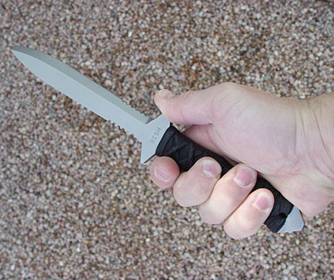
Beshara's XSF-1 has an excellent balance and fits the hand well in both standard and reverse grip.
I got my first real look at the XSF-1 at the 2004 International Blade Show and immediately knew that it would be a hit. I also knew that the demand for this distinctive knife would soon outgrow Beshara's ability to produce it on a custom basis, so I asked him if he'd be interested in discussing commercial production of the design. To make a long story short, he was interested, and so was Jim Ray, founder and Brand Manager of the Masters of Defense knife company.
To assist in the development of the production version of the XSF-1, and to help recognize Beshara's custom expression of it, I received several versions of this unique knife for evaluation.
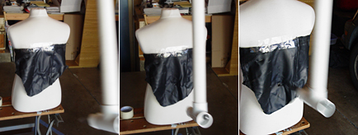
To scientifically test the penetration performance of the Beshara XSF-1, the author constructed a ballistic pendulum that allowed it to strike a foam torso with uniform force. The results were compared with a variety of other blade and point designs
Although I had no doubts that Beshara had validated the XSF-1 design as an effective thrusting weapon in his own tests, I wanted to quantify its performance by comparing it to more traditional point designs. To do this objectively, I needed a method of controlled, scientific testing. After a little thought, I came up with a simple, effective and consistent method of thrusting knives into a target of uniform density. The target was a brand new foam mannequin torso, which I clamped into a Workmate workstation. The fixture for holding the knife was a six-foot-long ballistic pendulum made from 1-1/2-inch PVC pipe that swung from a steel pivot attached to a rafter in my garage.
To perform the tests, I fitted each knife into the end of the pendulum, raised it to a consistent height, and let it swing down under its own weight to penetrate the torso. I did this three times each with the bare torso and with a piece of leather jacket material over the torso, making sure to hit a clean spot every time.
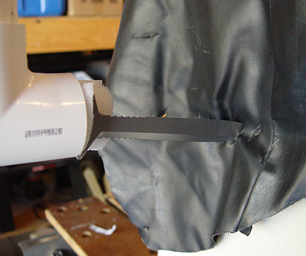
These tests revealed that the XSF-1 consistently penetrated on par with single-edged tantos and traditional Bowie designs, but not quite as well as conventional double-edged daggers. Bear in mind, though, that the XSF-1 also does not suffer from the primary weakness of conventional daggers - a weak and easily broken point. When considered in this context, the extreme durability of the XSF-1's point is much more important than the slightly better penetration offered by traditional daggers.
In addition to the pendulum testing, I also did a lot of subjective, hand-held thrusting tests with this unusual knife. I found that even when the target torso was covered with heavy clothing, the XSF-1 penetrated exceedingly well.
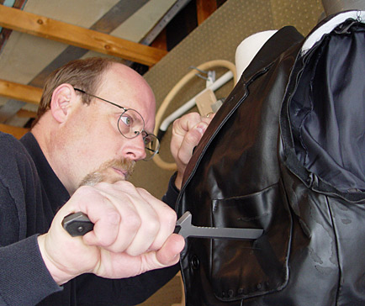
The XSF-1 is intended primarily as a thrusting weapon. Here the author tests it against a foam mannequin torso covered in a leather jacket, with very impressive results
Cutting tests with the XSF-1 also produced some very interesting results. During ballistic cutting tests (slashing at a target), its steep chisel edges cut well, but not nearly as deeply as knives with a more acute edge geometry. However during pressure cuts (cuts that start with the edge in contact with the target), the XSF-1 performed as well or better than most of the competition. I also found that its distinctive triple-edged tip produced spectacular cuts when employed with snap cuts and Bowie-style back cuts. During these movements, the square edges of the tip penetrated and cut in opposite directions, producing deep cuts with a minimum of force.
In short, I found the XSF-1 to be a dramatic and highly functional evolution of the military dagger concept. As a close-combat tool, it provides the capability of devastating snap and back cuts at long range, effective draw cuts at close-range, and incredible penetration at all ranges.
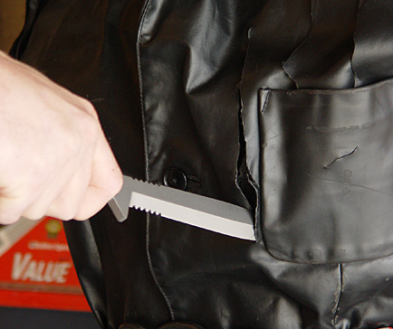
With so much going for it, it should be no surprise that the XSF-1 has attracted the attention of others in the knife industry as well. In fact, at the 2004 Blade Show, Jim Ray of the Masters of Defense knife company struck a deal with Beshara to produce a commercial version of this unusual design. MOD is also pursuing patent application for Besh Wedge Technology to ensure that Beshara receives proper credit and protection for his innovative design.
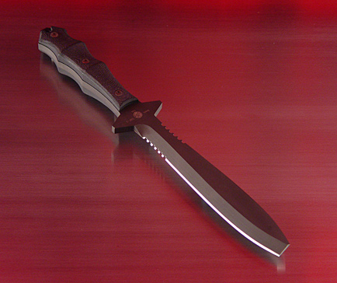
In addition to Beshara's custom versions of the XSF-1, it will also be produced commercially by Masters of Defense. Shown here is a pre-production prototype of the MOD version. Note the contoured handle slabs
The MOD version of the XSF-1 will be made of A-2 tool steel for maximum toughness and will be coated with Diamond Black DLC for corrosion resistance and its non-reflective qualities. Contoured G-10 handle slabs will replace Beshara's flat textured G-10, but the knife will otherwise be a faithful rendition of Beshara's custom work. An all-titanium version of the design is also in the works and should find favor with ordnance specialists looking for the ultimate non-ferrous probe.
The XSF-1 is one of the most unique designs to hit the knife world in a long time and represents an outstanding combination of innovative design, expert engineering, and high-quality execution. Whether you choose one of Brent Beshara's custom renditions or the Masters of Defense commercial version (slated for release in mid 2005), you will be getting both a potent close-combat tool and a significant piece of edged-weapon history.
For more information, contact: Besh Knives, 207 Cedar Street, P.O. Box 1046, Stayner, Ontario L0M 1S0 Canada, beshknives@sympatico.ca or Masters of Defense, 4850 Brookside Court, Norfolk, VA 23502, 800-694-5263, Contact: http://www.modknives.com
Contact: http://www.beshknives.com

