Member Tested and Recommended Program

Friday, July 31, 2026

Thank you for participating in our “Member Tested and Recommended Products Program.” The XSF Punch Dagger has been tested and recommended by the members of the National Tactical Officers Association. Your overall score was a 4.8 The NTOA Member Tested and Recommended logo may be used solely on the specific product that was tested.

Attached with this letter, is the Member Tested and Recommended Logo which can be used on all marketing pieces for this product. Also attached is a copy of the complete reviews that your company can use as well.

Press releases written regarding this product review must be emailed to NTOA for review before release.

Since the review is completed, it will now be added to online Member Tested product database. To make the review complete, please send us a digital image of the product that has been tested. This is now listed on the NTOA’s Member Tested and Recommended online database and review will soon be published in The Tactical Edge journal.

Please contact Corey Luby at advertising@ntoa.org if you would like to advertise in The Tactical Edge journal. Once again, thank you for participating Member Tested and Recommended Program©.

Thank you,
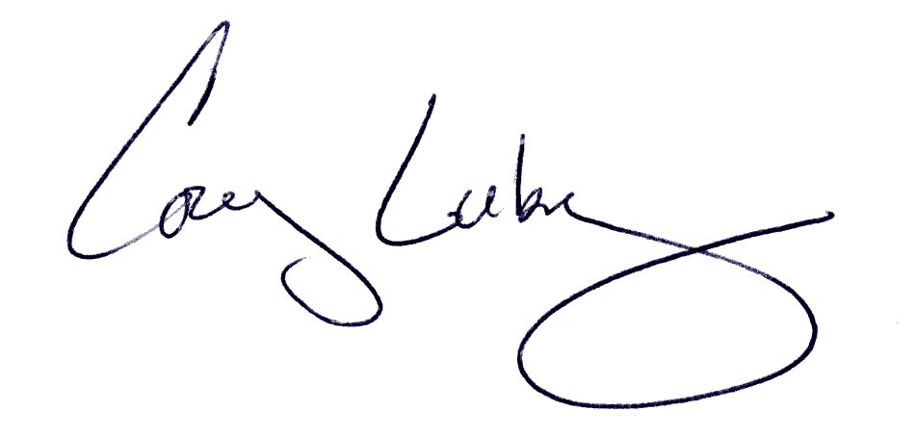

Corey Luby
800-279-9127x120

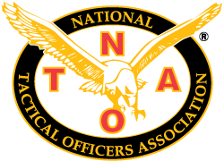
Blackhawk Products Group
XSF Punch Dagger
Overall Score: 4.8
http://www.blackhawk.com

TESTER
Tested by a police officer from California
Design 4
Performance 5
Ease of Use 5
Size 5
Quality 5
Durability 5
Storage 5
Versatility 4
Convenience 4
Application 5
Comfort 4
Accuracy
Cleaning & Maintenance 5
Individual Score 4.67
Blackhawk has done it again. They've made a top quality knife/dagger that is great as a defensive weapon too. The XFS Punch Dagger was designed to be worn around the neck or you can modify it and wear around your belt. The XFS Dagger also comes with a quality sheath for safe storage.

The XFS is made of high quality metal and also has a quick non-skip grip. The dagger can be manipulated with two fingers and holds solid in the user’s hand. I work this item for a few weeks on patrol and SWAT training. Its light weight and overall a good piece of equipment.

I would definitely recommend owning this dagger and I will make sure to wear this often as part of my equipment.

TESTER
Tested by a police officer from Colorado
Design 5
Performance 4.8
Ease of Use 5
Size 5
Quality 5
Durability 4.8
Storage 4.9
Versatility 5
Convenience 4.8
Application 5.0
Comfort 5
Accuracy
Cleaning & Maintenance 4.8
Individual Score 4.93
The Blackhawk “XSF Punch Dagger” is an outstanding piece of duty gear and I highly recommend it for both on duty work and off-duty. The punch dagger is light weight and easy to conceal worn as chain. I was surprised how light weight and easy it was to secure the dagger in its plastic case for a fast pull and punch deployment.

The dagger handle allows for an easy grab and control as it is remove the plastic case. The blade is light weight yet strong and has a very sharp point. The blade was not to long and has a nice sharp cutting surface and a strong point. The plastic holding case is well made and has a lipped edge that allows for easy assess while trying to return the blade into the case.

I was also impressed with how easy and smooth it was to return the dagger into the case and feel it lock into place.
As a defensive last resort weapon it works with its light construction and easy ability to conceal it. The dagger is a very nice Blackhawk product with some excellent workmanship put into it.

